Neeraj Appari S073

Prac6:

Aim: Create an android app that demonstrates the use of Alerts, DatePicker and TimePicker dialogs.

Code:

Java

package com.example.datepickerp6;

import androidx.appcompat.app.AppCompatActivity;

import android.app.DatePickerDialog;

import android.app.TimePickerDialog;

import android.os.Bundle;

import android.view.View;

import android.widget.DatePicker;

import android.widget.EditText;

import android.widget.TimePicker;

import java.util.Calendar;

public class MainActivity extends AppCompatActivity {

int mYear, mMonth, mDay, mHour, mMinute;

EditText e1, e2;

@Override

protected void onCreate(Bundle savedInstanceState){

super.onCreate(savedInstanceState);

setContentView(R.layout.activity_main);

e1 = findViewById(R.id.in_date);

e2 = findViewById(R.id.in_time);

}

public void showDate(View view)

{

final Calendar c = Calendar.getInstance();

mYear = c.get(Calendar.YEAR);

mMonth = c.get(Calendar.MONTH);

mDay = c.get(Calendar.DAY_OF_MONTH);

DatePickerDialog datePickerDialog = new DatePickerDialog(this,

new DatePickerDialog.OnDateSetListener()

{

@Override

public void onDateSet(DatePicker view, int year,

int monthOfYear, int dayOfMonth)

{

e1.setText(dayOfMonth + "-" + (monthOfYear + 1) + "-" + year);

}

}, mYear, mMonth, mDay);

datePickerDialog.show();

}

public void showTime(View view)

{

final Calendar c = Calendar.getInstance();

mHour = c.get(Calendar.HOUR_OF_DAY);

mMinute = c.get(Calendar.MINUTE);

TimePickerDialog timePickerDialog = new TimePickerDialog(this,

new TimePickerDialog.OnTimeSetListener() {

@Override

public void onTimeSet(TimePicker view, int hourOfDay,

int minute) {

e2.setText(hourOfDay + ":" + minute);

}

}, mHour, mMinute, false);

timePickerDialog.show();

}

}

<?xml version="1.0" encoding="utf-8"?>

<RelativeLayout xmlns:android="http://schemas.android.com/apk/res/android"

xmlns:app="http://schemas.android.com/apk/res-auto"

xmlns:tools="http://schemas.android.com/tools"

android:layout_width="match_parent"

android:layout_height="match_parent"

tools:context=".MainActivity">

<EditText

android:id="@+id/in_date"

android:layout_width="200dp"

android:layout_height="wrap_content"

android:layout_alignParentStart="true"

android:layout_alignParentLeft="true"

android:layout_alignParentTop="true"

android:layout_marginStart="179dp"

android:layout_marginLeft="179dp"

android:layout_marginTop="246dp" />

<Button

android:id="@+id/btn_date"

android:layout_width="wrap_content"

android:layout_height="wrap_content"

android:layout_alignBottom="@+id/in_date"

android:layout_marginStart="-356dp"

android:layout_marginLeft="-356dp"

android:layout_marginBottom="-7dp"

android:layout_toEndOf="@+id/in_date"

android:layout_toRightOf="@+id/in_date"

android:background="#5E2424"

android:backgroundTint="#913434"

android:onClick="showDate"

android:text="SELECT DATE" />

<EditText

android:id="@+id/in_time"

android:layout_width="200dp"

android:layout_height="wrap_content"

android:layout_below="@+id/in_date"

android:layout_alignParentStart="true"

android:layout_alignParentLeft="true"

android:layout_marginStart="177dp"

android:layout_marginLeft="177dp"

android:layout_marginTop="152dp" />

<Button

android:id="@+id/btn_time"

android:layout_width="wrap_content"

android:layout_height="wrap_content"

android:layout_below="@+id/btn_date"

android:layout_alignStart="@+id/btn_date"

android:layout_alignLeft="@+id/btn_date"

android:layout_marginStart="6dp"

android:layout_marginLeft="6dp"

android:layout_marginTop="150dp"

android:onClick="showTime"

android:text="SELECT TIME" />

<EditText

android:id="@+id/editTextTextPersonName"

android:layout_width="wrap_content"

android:layout_height="52dp"

android:layout_alignParentTop="true"

android:layout_alignParentEnd="true"

android:layout_marginTop="105dp"

android:layout_marginEnd="115dp"

android:background="@drawable/ic_launcher_background"

android:backgroundTint="#531C1C"

android:ems="10"

android:inputType="textPersonName"

android:textColor="@color/white" />

<TextView

android:id="@+id/textView3"

android:layout_width="167dp"

android:layout_height="49dp"

android:layout_alignParentTop="true"

android:layout_alignParentEnd="true"

android:layout_marginTop="44dp"

android:layout_marginEnd="144dp"

android:background="#03A9F4"

android:text="Practical 6"

android:textSize="24sp" />

</RelativeLayout>

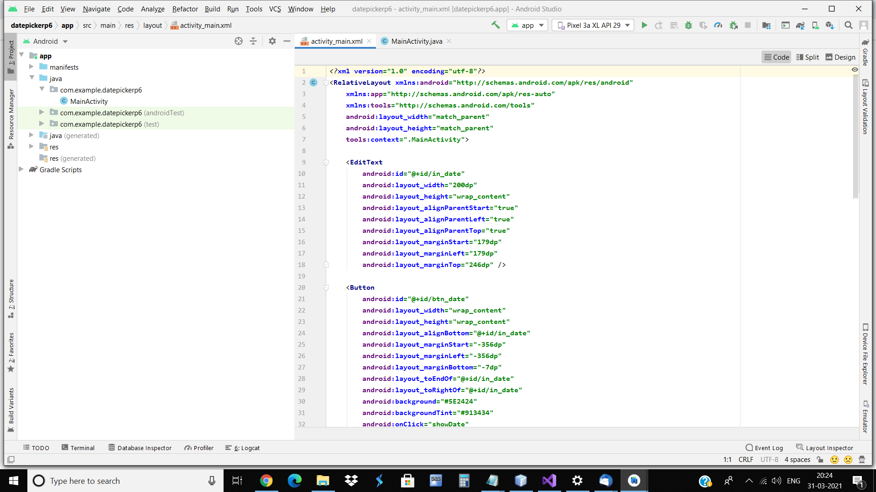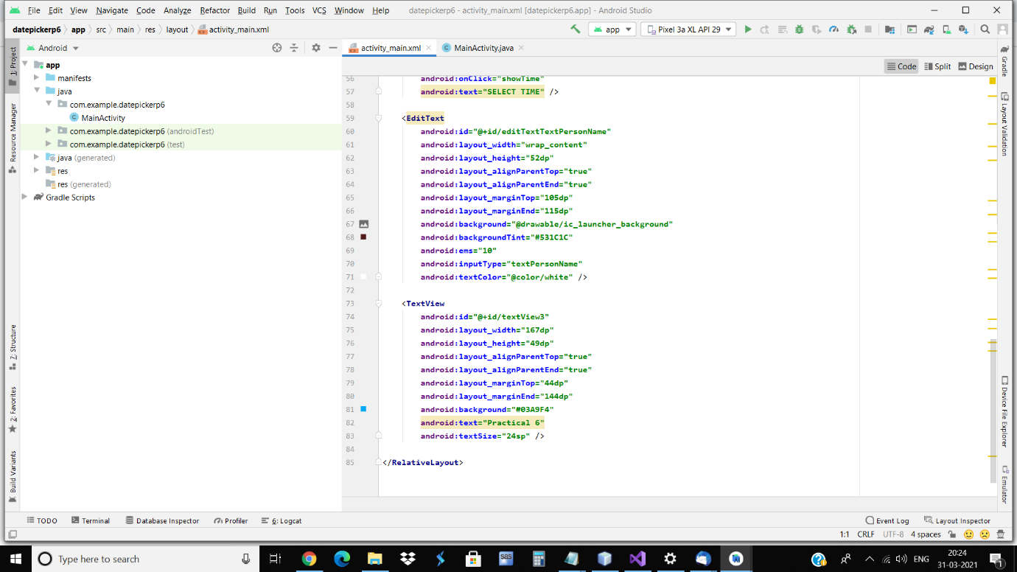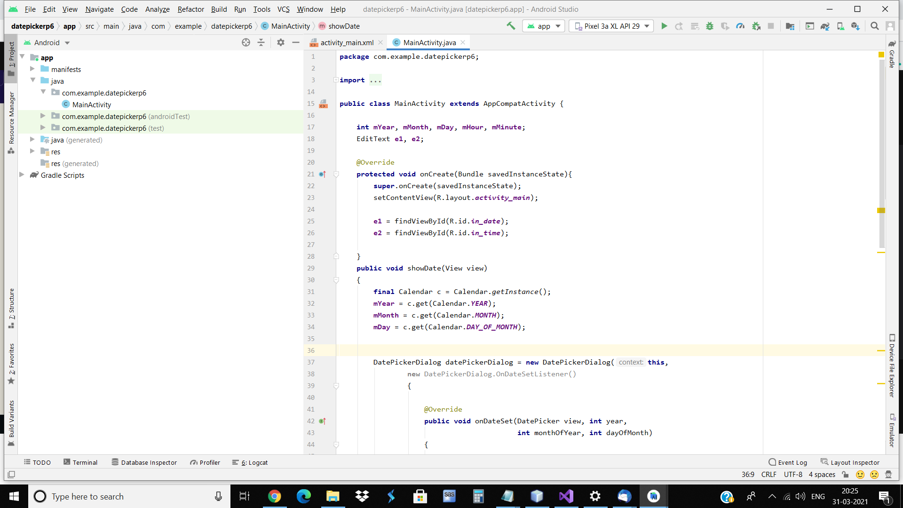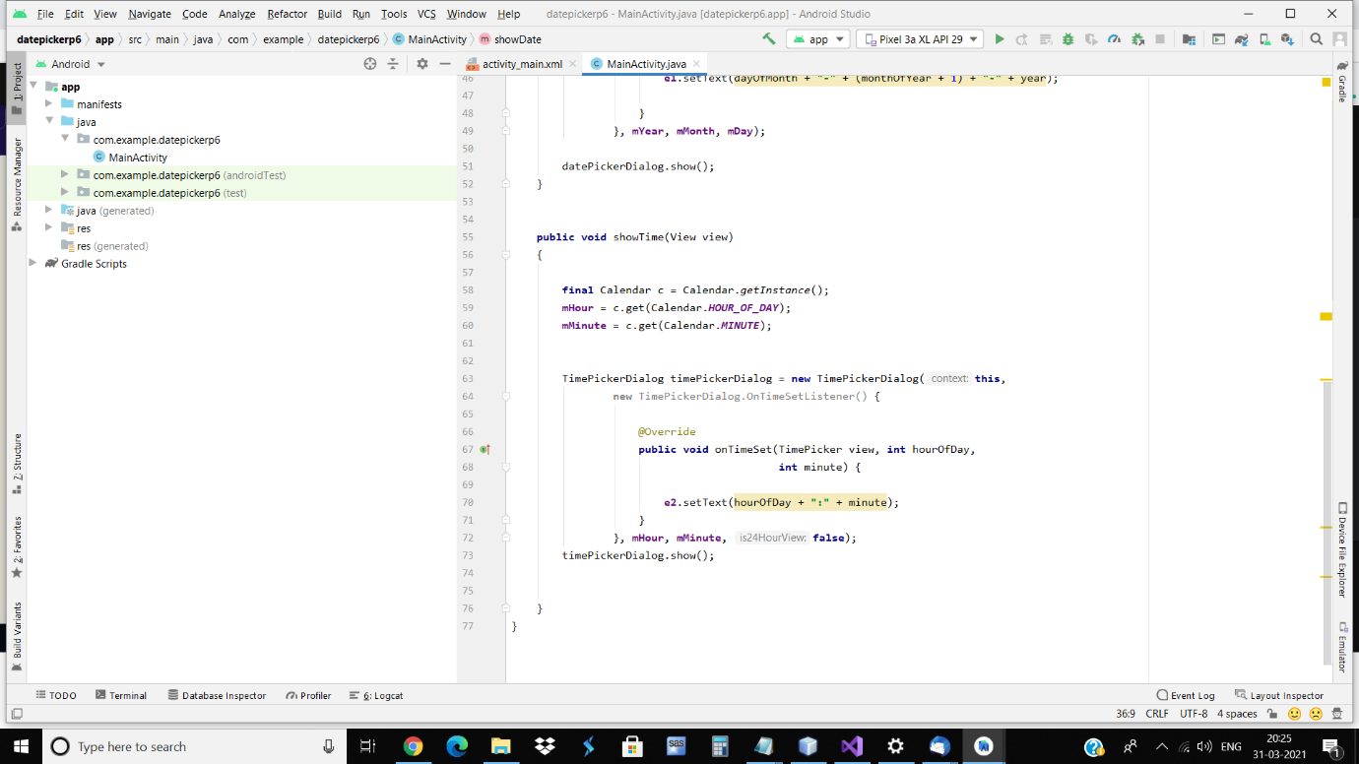

Prac7:

Aim: Create an android app to demonstrate BroadcastReceiver.

<?xml version="1.0" encoding="utf-8"?>

<RelativeLayout xmlns:android="http://schemas.android.com/apk/res/android"

xmlns:app="http://schemas.android.com/apk/res-auto"

xmlns:tools="http://schemas.android.com/tools"

android:layout_width="match_parent"

android:layout_height="match_parent"

tools:context=".MainActivity">

<TextView

android:layout_width="156dp"

android:layout_height="40dp"

android:layout_alignParentStart="true"

android:layout_alignParentTop="true"

android:layout_marginStart="136dp"

android:layout_marginTop="264dp"

android:background="#9E8B8B"

android:text="Broadcast Receiver" />

<EditText

android:id="@+id/editTextTextPersonName"

android:layout_width="wrap_content"

android:layout_height="52dp"

android:layout_alignParentTop="true"

android:layout_alignParentEnd="true"

android:layout_marginTop="105dp"

android:layout_marginEnd="115dp"

android:background="@drawable/ic_launcher_background"

android:backgroundTint="#531C1C"

android:ems="10"

android:inputType="textPersonName"

android:textColor="@color/white" />

<TextView

android:id="@+id/textView3"

android:layout_width="167dp"

android:layout_height="49dp"

android:layout_alignParentTop="true"

android:layout_alignParentEnd="true"

android:layout_marginTop="44dp"

android:layout_marginEnd="144dp"

android:background="#03A9F4"

android:text="Practical 7"

android:textSize="24sp" />

</RelativeLayout>

package com.example.broadcastp7;

import androidx.appcompat.app.AppCompatActivity;

import android.os.Bundle;

public class MainActivity extends AppCompatActivity {

@Override

protected void onCreate(Bundle savedInstanceState) {

super.onCreate(savedInstanceState);

setContentView(R.layout.activity_main);

}

}

package com.example.broadcastp7;

import android.content.BroadcastReceiver;

import android.content.Context;

import android.content.Intent;

import android.util.Log;

import android.widget.Toast;

public class MyBroadcastReceiver extends BroadcastReceiver

{

private static final String TAG = "MyBroadcastReceiver";

@Override

public void onReceive(Context context, Intent intent)

{

StringBuilder sb = new StringBuilder();

sb.append("Action: " + intent.getAction() + "\n");

sb.append("URI: " + intent.toUri(Intent.URI_INTENT_SCHEME).toString() + "\n");

String log = sb.toString();

Log.d(TAG, log);

Toast.makeText(context, log, Toast.LENGTH_LONG).show();

}

}

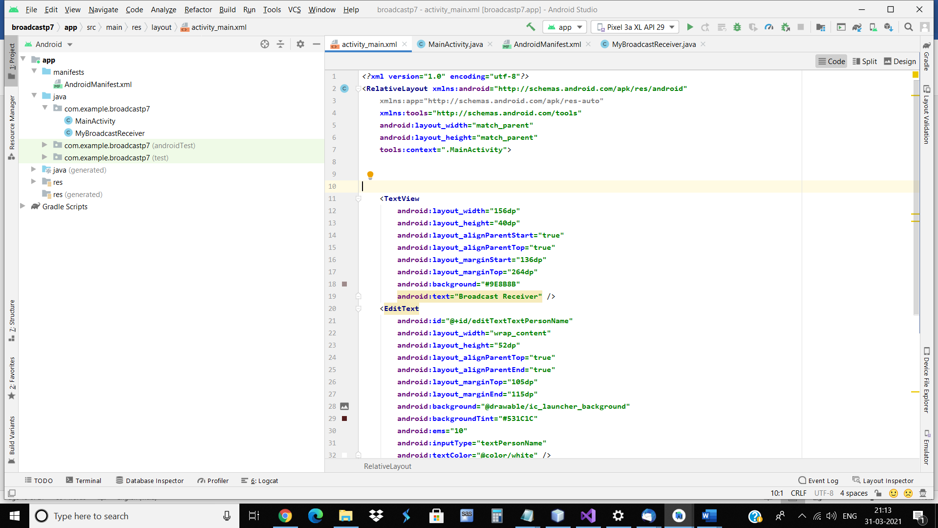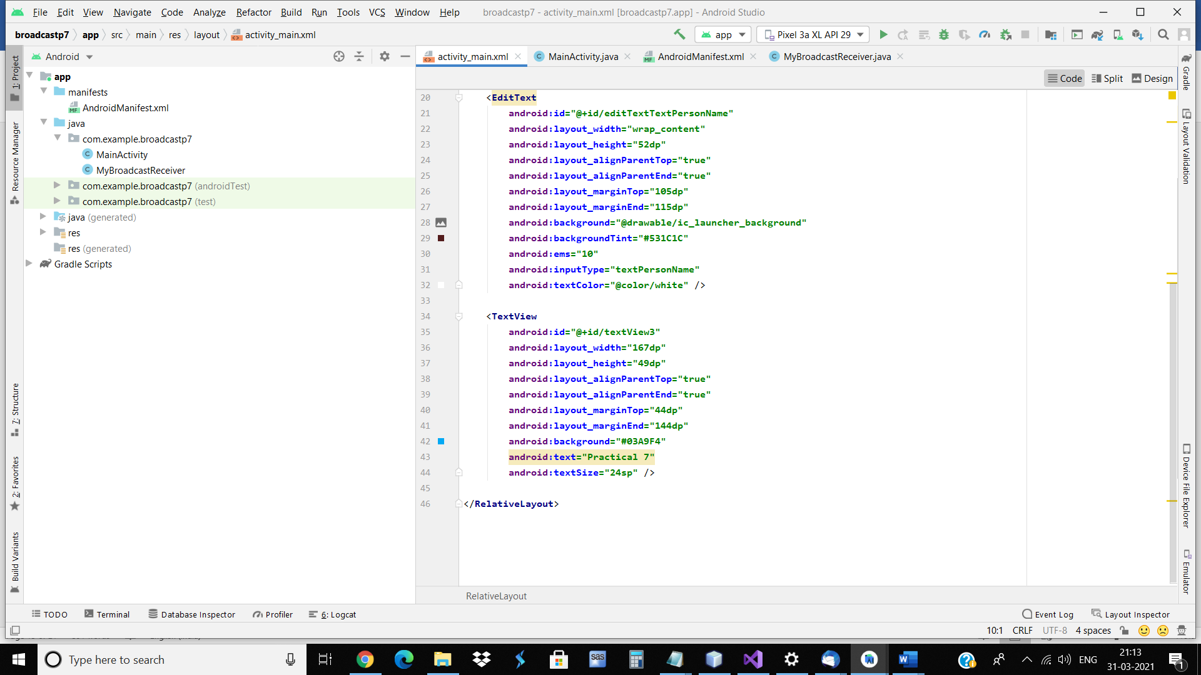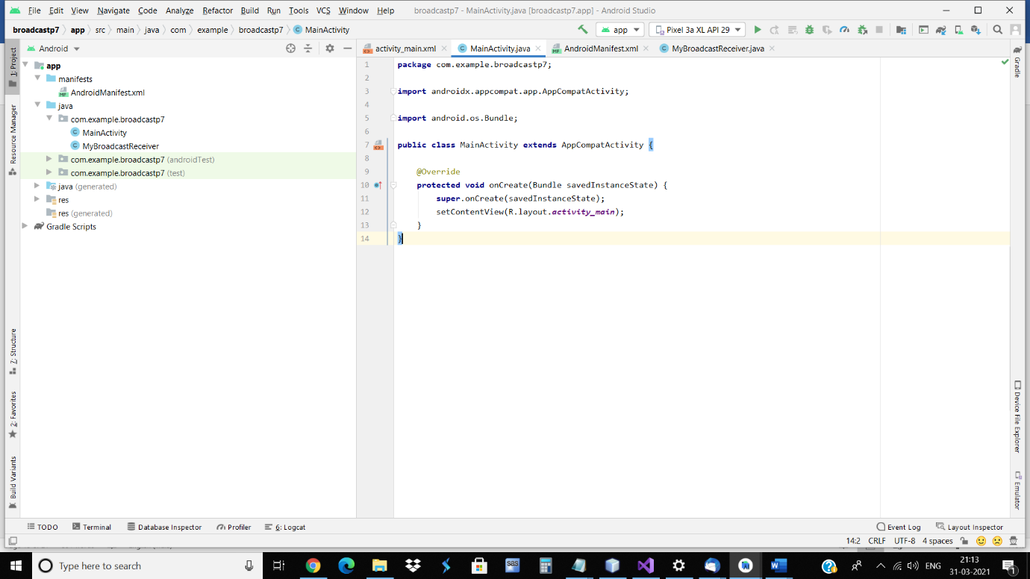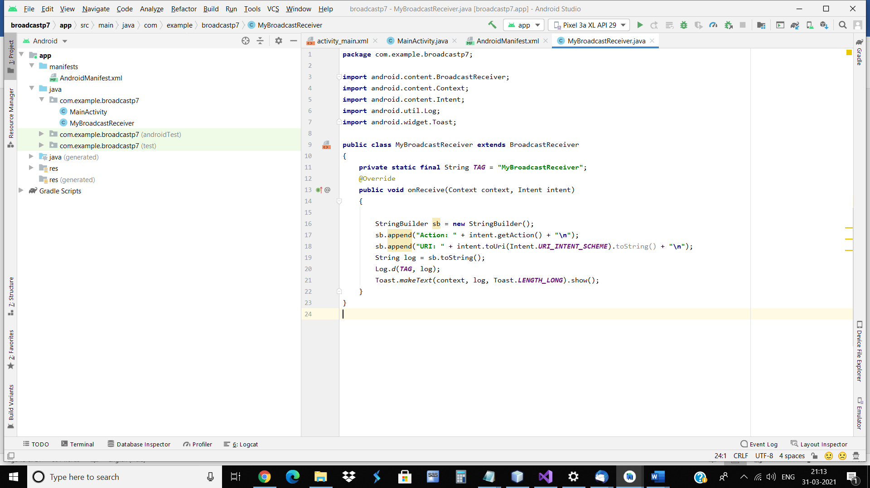

Prac8:

Aim: Create an android app to show Notifications.

code:

<?xml version="1.0" encoding="utf-8"?>

<RelativeLayout xmlns:android="http://schemas.android.com/apk/res/android"

xmlns:app="http://schemas.android.com/apk/res-auto"

xmlns:tools="http://schemas.android.com/tools"

android:layout_width="match_parent"

android:layout_height="match_parent"

tools:context=".MainActivity">

<EditText

android:id="@+id/editTextTextPersonName"

android:layout_width="wrap_content"

android:layout_height="52dp"

android:layout_alignParentTop="true"

android:layout_alignParentEnd="true"

android:layout_marginTop="105dp"

android:layout_marginEnd="115dp"

android:background="@drawable/ic_launcher_background"

android:backgroundTint="#531C1C"

android:ems="10"

android:inputType="textPersonName"

android:textColor="@color/white" />

<TextView

android:id="@+id/textView3"

android:layout_width="167dp"

android:layout_height="49dp"

android:layout_alignParentTop="true"

android:layout_alignParentEnd="true"

android:layout_marginTop="44dp"

android:layout_marginEnd="144dp"

android:background="#03A9F4"

android:text="Practical 8"

android:textSize="24sp" />

<Button

android:id="@+id/btnCreate"

android:layout_width="wrap_content"

android:layout_height="wrap_content"

android:layout_alignParentTop="true"

android:layout_alignParentEnd="true"

android:layout_marginTop="304dp"

android:layout_marginEnd="121dp"

android:onClick="CreateNotification"

android:text="Create Notification" />

</RelativeLayout>

package com.example.notificationp8;

import androidx.appcompat.app.AppCompatActivity;

import androidx.core.app.NotificationCompat;

import android.app.Notification;

import android.app.NotificationManager;

import android.app.PendingIntent;

import android.content.Intent;

import android.os.Bundle;

import android.view.View;

public class MainActivity extends AppCompatActivity {

@Override

protected void onCreate(Bundle savedInstanceState) {

super.onCreate(savedInstanceState);

setContentView(R.layout.activity_main);

}

int notifyID = 1;

int numMessages = 0;

public void CreateNotification(View v)

{

numMessages+=1;

NotificationManager notificationManager = (NotificationManager) getSystemService(NOTIFICATION_SERVICE);

Intent intent = new Intent(this, SecondActivity.class);

PendingIntent pIntent = PendingIntent.getActivity(this, (int) System.currentTimeMillis(), intent, 0);

NotificationCompat.Builder n = new NotificationCompat.Builder(this)

.setContentTitle("Notification App")

.setContentText("welcome to my notification")

.setContentIntent(pIntent)

.setSmallIcon(R.mipmap.ic_launcher)

.setNumber(numMessages)

.setAutoCancel(true);

notificationManager.notify(notifyID, n.build());

}

}

package com.example.notificationp8;

import androidx.appcompat.app.AppCompatActivity;

import android.os.Bundle;

import android.app.Activity;

public class SecondActivity extends AppCompatActivity{

@Override

public void onCreate(Bundle savedInstanceState){

super.onCreate(savedInstanceState);

setContentView(R.layout.activity_second);

}

}

<?xml version="1.0" encoding="utf-8"?>

<RelativeLayout

xmlns:android="http://schemas.android.com/apk/res/android" android:layout_width="match_parent"

android:layout_height="match_parent">

<TextView

android:id="@+id/textView"

android:layout_width="wrap_content"

android:layout_height="wrap_content"

android:layout_alignParentTop="true"

android:layout_centerHorizontal="true"

android:layout_marginTop="207dp"

android:text="This is Sample Activity" />

</RelativeLayout>

